EXPERIMENT – 10
K-MEANS CLUSTERING
Aim:
To perform model clustering using K-means Clustering technique

Procedure:
1. Upload the given dataset
2. Import all the necessities
3. Read the dataset as Data Frame
4. Using seaborn visualize the trends
5. Using sklearn train the model for predicting

Program:
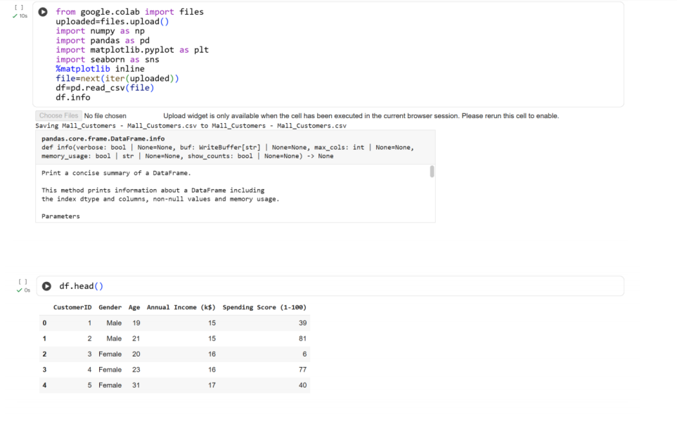
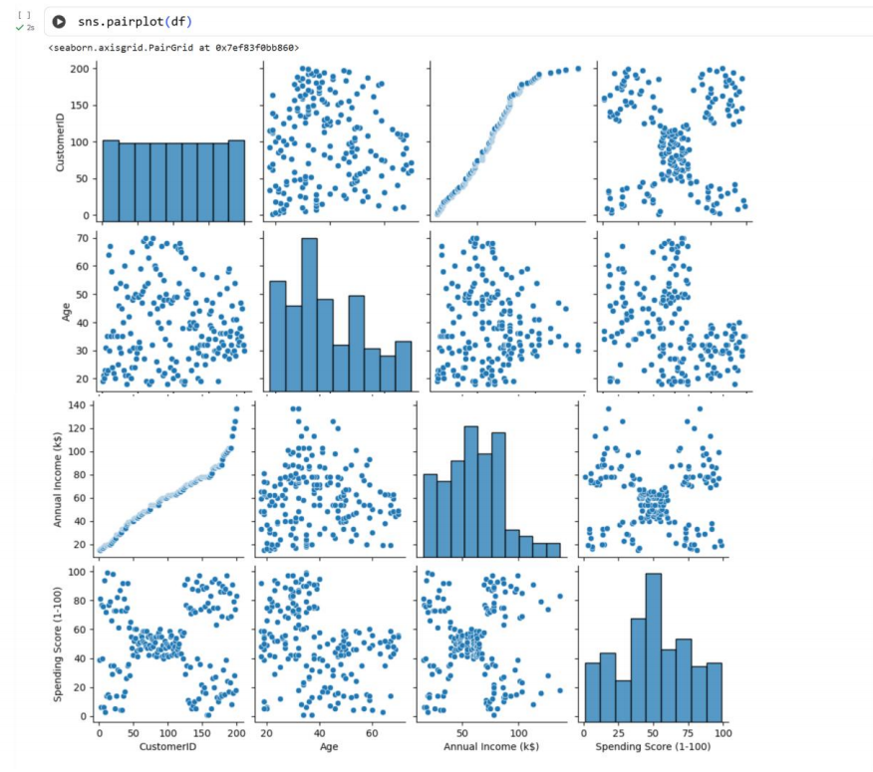
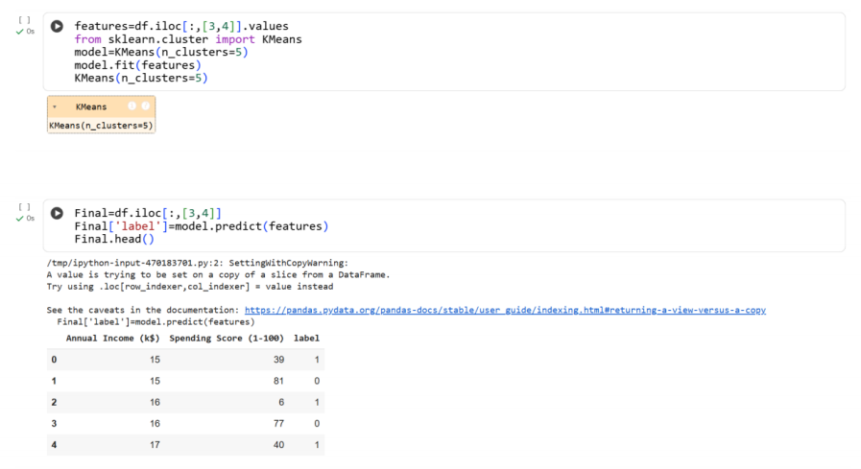
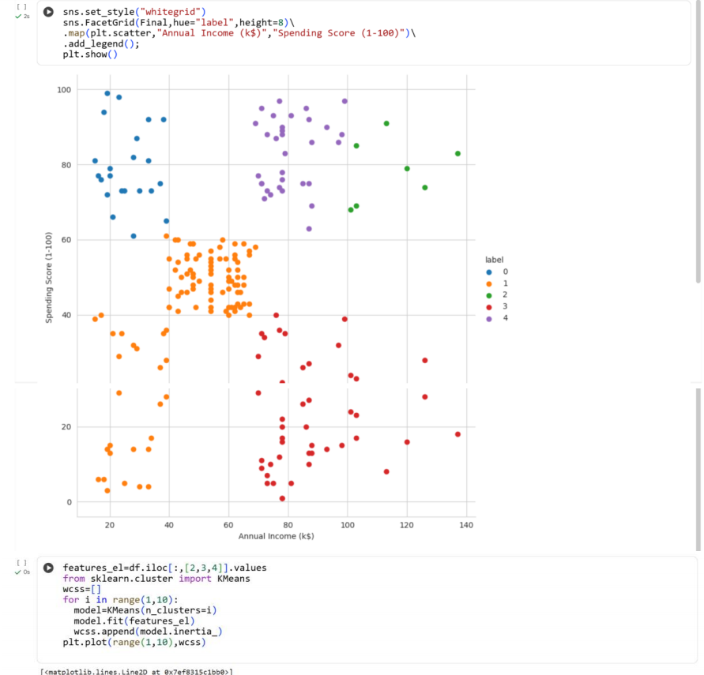
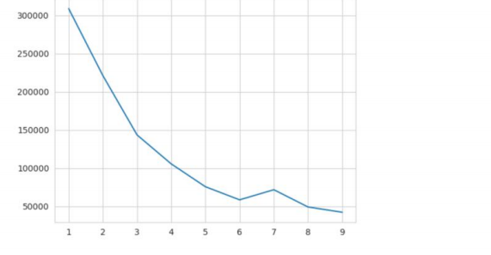

Result:
Thus the python program to make prediction model using K-means Clustering is
executed and verified successfully

